EVENT SCHEDULE

7:15 AM
Registration

8:30 AM
Reverse Shotgun Start
Four Player Scramble
Reception immediately following

1:00 PM(Appx.)
Italian Buffet
CASH PRIZES
Awards & Opportunity Drawing
Presentations

For more information:
NLPOA San Diego County Chapter
P.O. Box 122708
San Diego, CA 92112
http://nlpoasandiegocounty.com

Contact:
Rich Agundez, Jr.
619-571-6234
925mary@cox.net

David Ardilla
619-200-4926
dbardilla@cox.net

HENRY “HANK” DELGADO TENORIO
1937 – 2001

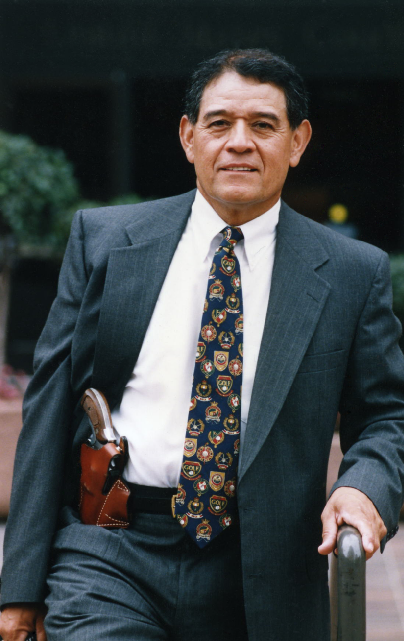

The tournament was first created by Hank Tenorio and NLPOA Founder Vicente Calderon in 1992. Since Hank’s passing in 2001, the NLPOA continues to host the event in his honor. Hank was a retired FBI agent, inspirational colleague, leader, mentor, friend and family member, who tirelessly gave back to the community.

Henry Delgado Tenorio was born on July 15, 1937 in Torrington, Wyoming where his family had been harvesting sugar beet crops. Henry coming from a less fortunate family graduated from Benedictine College (B.S.) and the University of Texas at El Paso (M.A.) He then joined the FBI in 1970. During his tenure as an FBI Agent, Henry specialized in kidnapping, anti-terrorism, bank robberies and hostage/crisis management. He became a liaison between the San Diego office and law enforcement agencies in Tijuana and Ensenada. This led to solving cases that would have been more difficult without his involvement. When he retired in 1994 he was the highest ranking Hispanic undercover agent in the FBI’s San Diego office.

Henry’s other passions were golf and community service. During his FBI career, he won several Police Olympics golf tournaments. Later, as a security consultant for the PGA tour, he befriended such pros as Lee Trevino and Chi Chi Rodriguez, once serving as a caddie for the latter. He later operated the Dos Amigos Foundation, which Mr. Rodriguez founded to raise funds for underprivileged children and orphanages in Mexico

The National Latino Peace Officers Association
San Diego County Chapter
Presents

HANK TENORIO MEMORIAL

“KEEP KIDS OUT OF THE ROUGH”

Golf Tournament & Lunch
Saturday, September 28, 2024

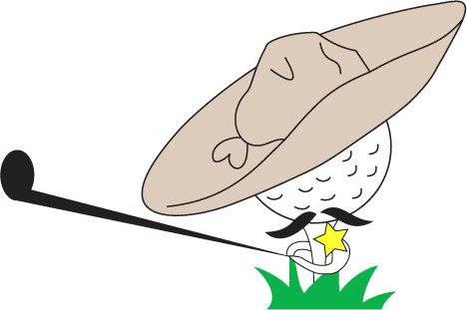

ONLY $125 per Player!
(Limited to the first 120 Players)
Active NLPOA Members - $110 Each

Early Bird
$110 Per person / $440 per Foursome
Paid by August 31, 2024
CASH PRIZES

Cottonwood Golf Club
3121 Willow Glen Drive
El Cajon, CA 92019

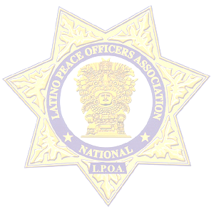

SPONSOR PACKAGE

Lunch Sponsor - $2500
One Foursome
Engraved Tequila Bottle
1 Year NLPOA Corporate Membership
1 Year NLPOA Website Advertising
Company Banner at Event
Recognition at Banquet

Drink Ticket Sponsor-$1250
Engraved Tequila Bottle
1 Year NLPOA Corporate Membership
1 Year NLPOA Website Advertising
Company Banner at Event
Recognition at Banquet

1st Place Trophy Sponsor-$1000
Engraved Tequila Bottle
1 yr. NLPOA Corporate Membership
1 Year NLPOA Website Advertising
Company Banner at Event
Recognition at Banquet

Golf Ball Sponsor-$750
Golf Balls with Your Company Logo
Given to Every Golfer
1 Year NLPOA Website Advertising
Company Banner at Event
Recognition at Event

Hole In One Sponsor-$750
Your Company Listed as HIO
Sponsor at 4 Different Tees
1 Year NLPOA Website Advertising
Banner Posted at Event
Recognition at Event

Goodie Bag Items OR Raffle Prizes
Recognition at Banquet

Player Early Bird
Entry Deadline: August 31, 2024

REGISTRATION

Team/Company:
_______________________________

______________________________________
Address
______________________________________
City State ZIP

______________________________________
Phone

Player 1(Team Captain)__________________

Email_________________________________

Wk#______________ Cell#_______________

Player 2_______________________________

Email_________________________________

Player 3_______________________________

Email_________________________________

Player 4_______________________________

Email_________________________________

Tee/Hole - $125
Company signage @ Tee or Hole

Signature:_____________________________

Date: _________Amt Enclosed $___________

The National Latino Peace Officers Association is a 501(C)3 Non- Profit Organization.
The “Keep Kids Out of the Rough” Golf Tournament will benefit the organization’s goals of community involvement including charitable donations and scholarship opportunities for youth pursuing careers in
law enforcement or related fields.

Complete form and mail to:
NLPOA San Diego County Chapter
Attn: Golf Tournament
P.O. Box 122708, San Diego, CA 92112
Make checks payable to:
National Latino Peace Officers Association
(Memo: “Keep Kids out of the Rough”)

VENMO
@NLPOASanDiegoCounty

WEBSITE
www.nlpoasandiegocounty.com
Use “DONATE” Tab

Contact or Email:
David Ardilla
619-200-4926
dbardilla@cox.net
OR
Rich Agundez, Jr.
619-571-6234
925mary@cox.net

The National Latino Peace Officers Association would like to thank EVERYONE for making this event possible. Whether you’re a Player, Volunteer or Corporation, its people like you that make a difference in the lives of
our youth and community.

